
SYSTEM ENGINEER
MARCH 2026
SAKSHI KISHOR GIRADKAR

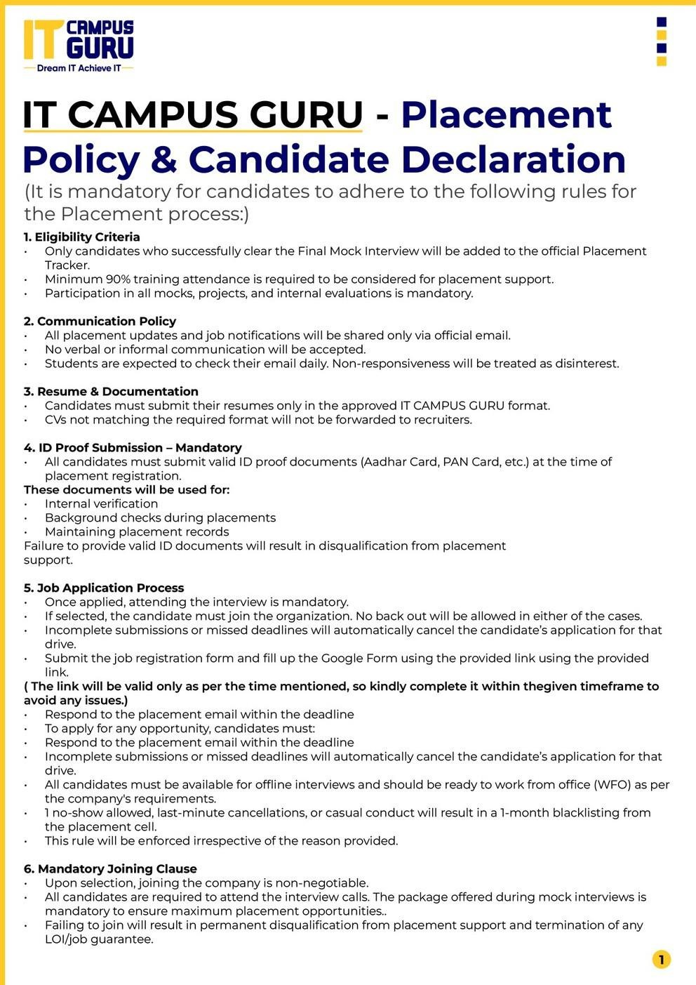

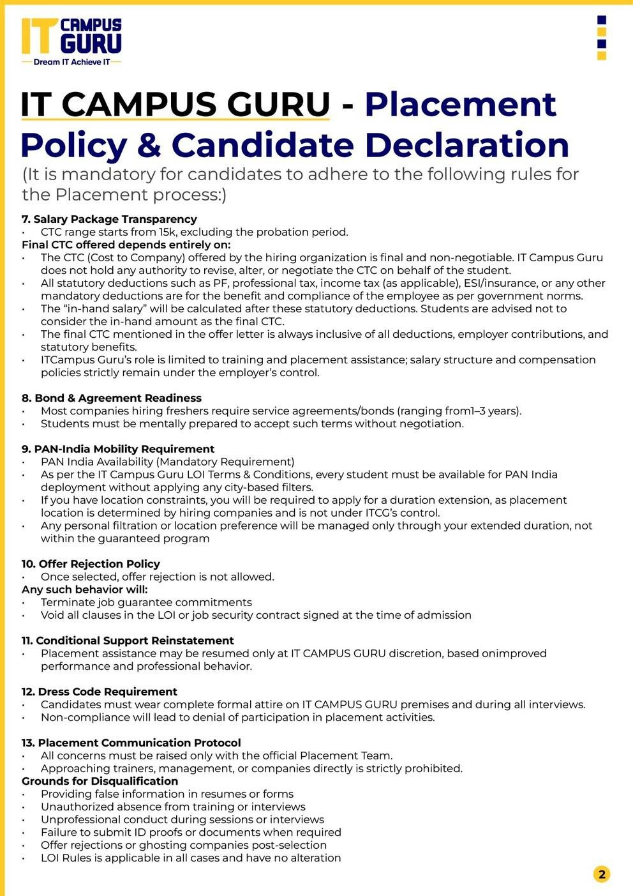

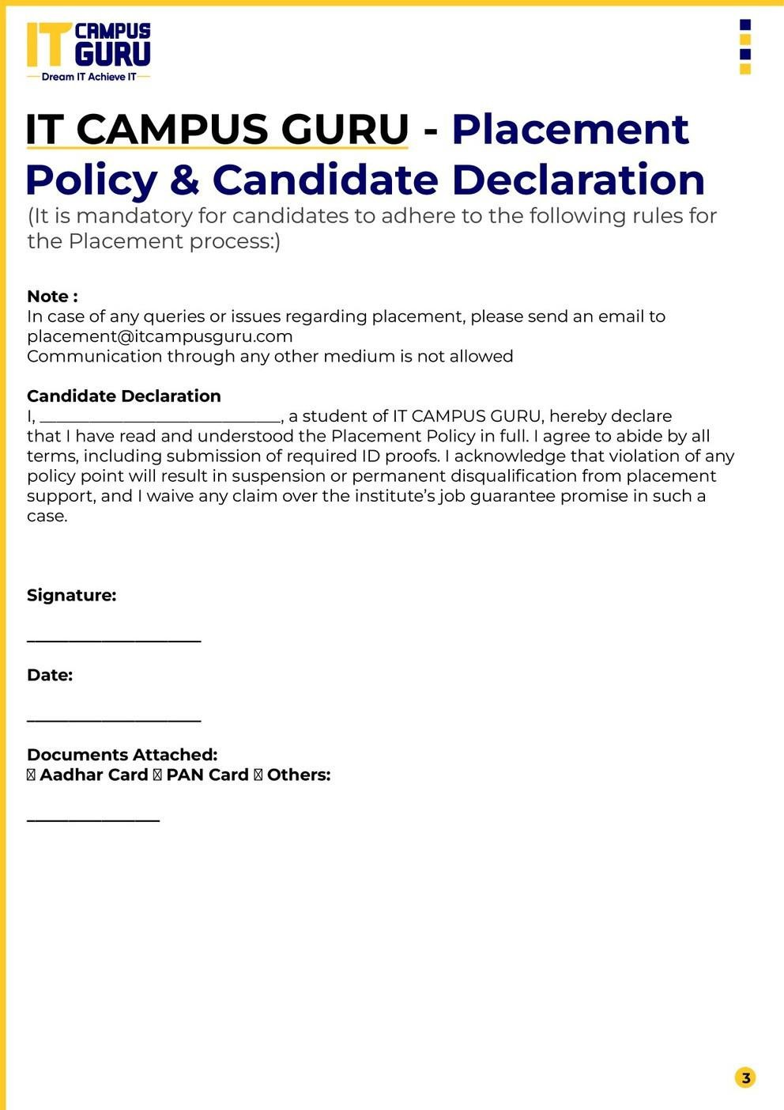
03-07-2026
2157 6094 5436
Aadhar Card
SAKSHI KISHOR GIRADKAR
SAKSHI KISHOR GIRADKAR
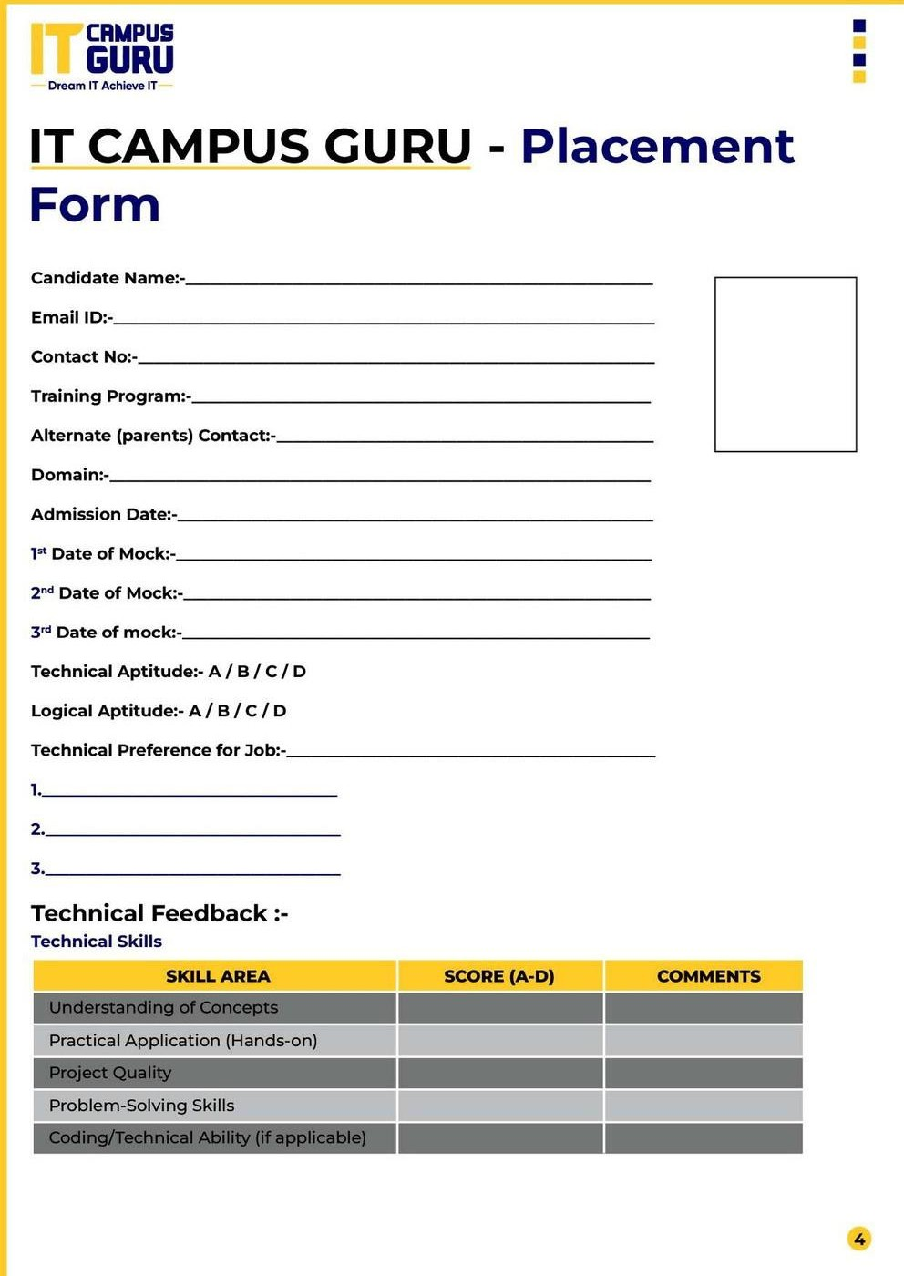
SAKSHI KISHOR GIRADKAR
sakshigiradka5@gmail.com
9356567875
23-12-2026
22-06-2026
29-06-2026
Nagpur,Pune,Mumbai,hydrabad
SYSTEM ENGINEER
DEKSTOP SUPPORT ENGINEER
NETWORK SUPPORT ENGINEER
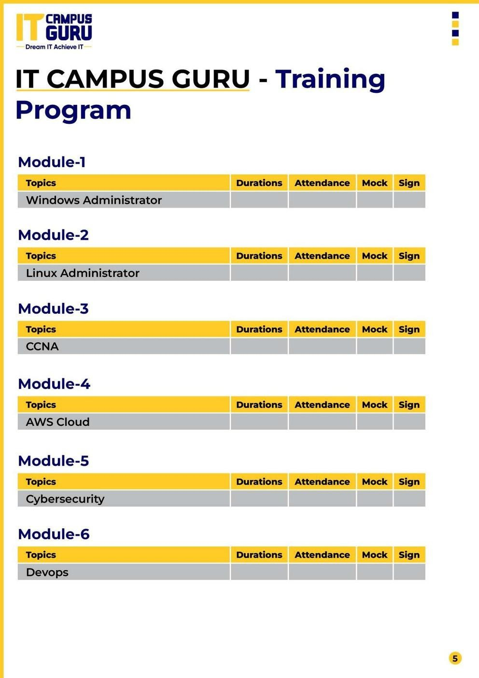

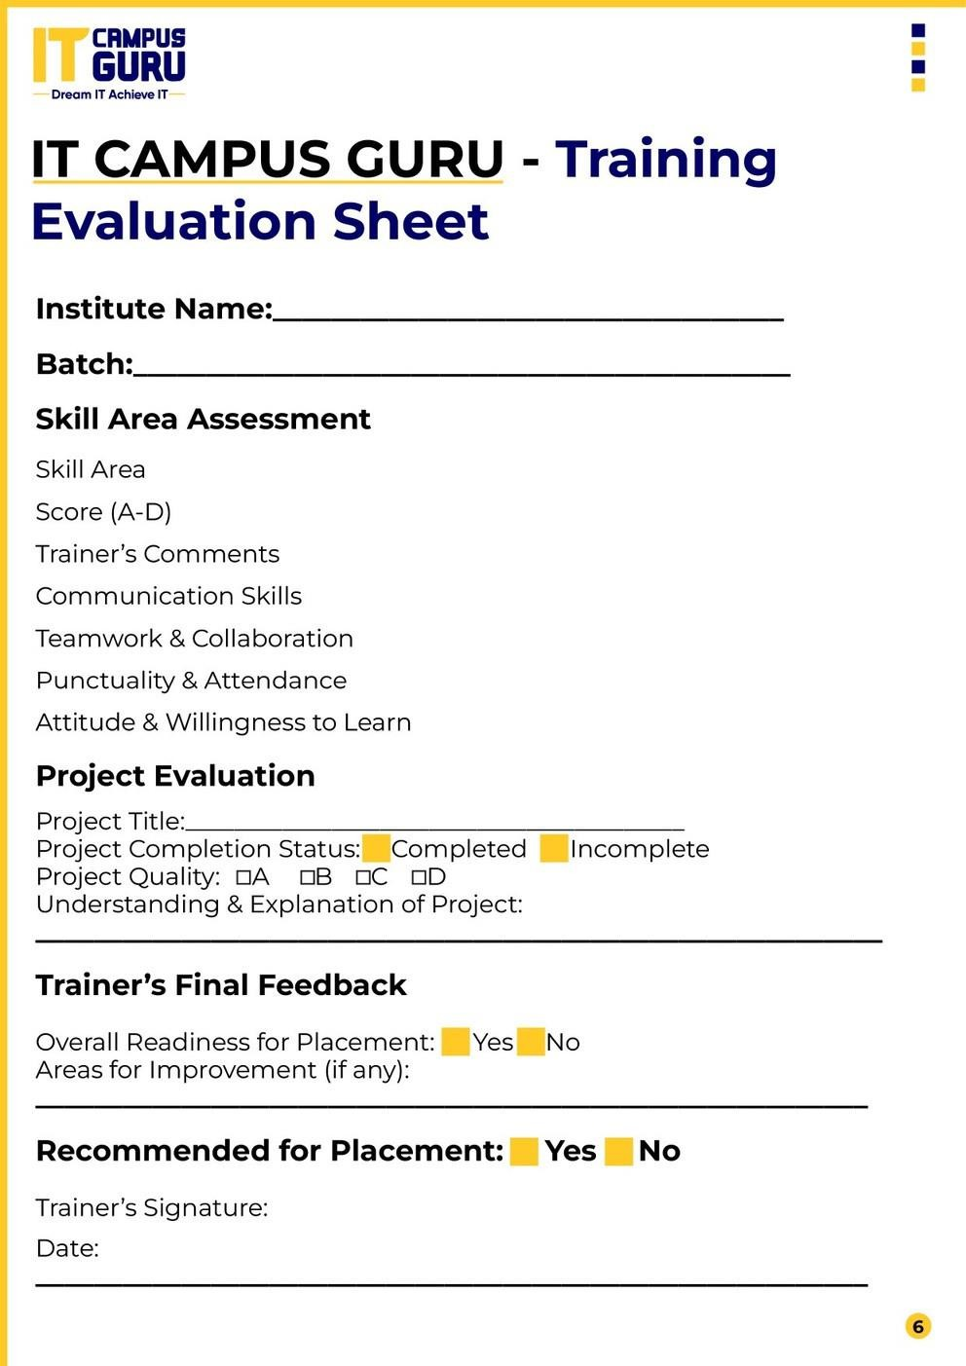

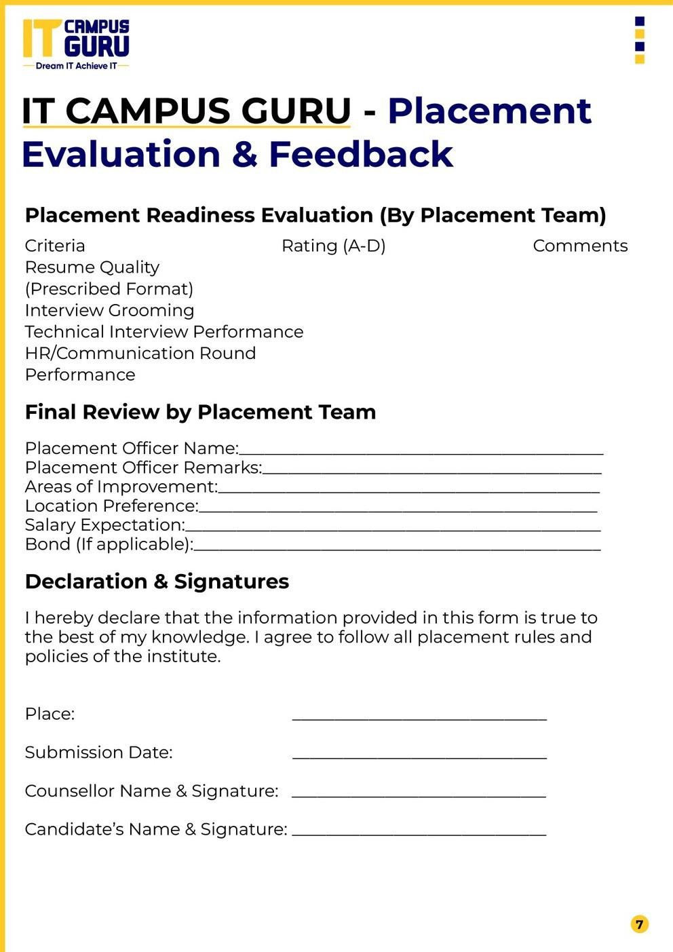
03-07-2026
Isha Chaturvedi
SAKSHI KISHOR GIRADKAR
NAGPUR

